HOME

About Seaweed and What & Where We Do

Ocean Is Feeding Us from Decades, Its Time Save Our Ocean –it’s a quotation

Adopt Seaweed

VseaweedO

Products

Contact

Career

Home page design

About Seaweed and What & Where We Do

**Ocean Is Feeding Us from Decades, Its Time Save Our Ocean** –it’s a quotation

Products

VseaweedO

**Adopt Seaweed**

ADOPT SEAWEED

Why To Adopt Seaweed

Seaweed cultivation, if it is adopted with the right strategy and especially at large scale, can be part of the solution to help mitigate biodiversity loss, excess nitrogen, ocean acidification, climate change and land use conflicts.

Why To Do Seaweed Cultivation:

Community Development

To provide alternate livelihood to fisherwomen / Women SHG Group families in the

To create avenues for additional income to Coastal fishers/ fisher women.

Production of seaweed which has manifold industrial benefits.

Carbon capture and storage

Seaweeds capture and store carbon dioxide captured carbon may become sequestered. One ton of seaweed can capture an estimated 120 kg of CO2, Seaweed farming can have a neutral or positive impact towards climate change and ocean acidification, depending on the use of the biomass and particularly when farmed in large-scale.

## Filtration and water quality

Seaweeds can filter excess inorganic nutrients from runoffs or fish aquaculture, which together with the added oxygen, help to improve water quality locally. With the right strategy and location of the farm, seaweeds can help increasing local biodiversity. One ton of seaweed can take up about 2 kg nitrogen and 0.2 kg phosphorus.

## Accommodation

Farmed seaweeds act as a temporary forest, providing food and shelter for small aquatic animals and fish. Studies have found that marine life is quickly re-established when a new seaweed crop is planted after harvesting. The seaweed habitat can increase local fish stocks by providing shelter to commercially important species, which can be fished in the vicinity of farms. natural seaweed beds support an estimated 10 kg of fish per 1 ton of Seaweed.

## Products

Seaweeds are nutritious and an environmentally friendly source of biomass for food, health products and animal feed. They help reduce the environmental footprint of other industries and stimulate collaboration for better use of resources and more sustainable products.

JOIN US WE REGORNIZES



Wrist Band 10 kgs

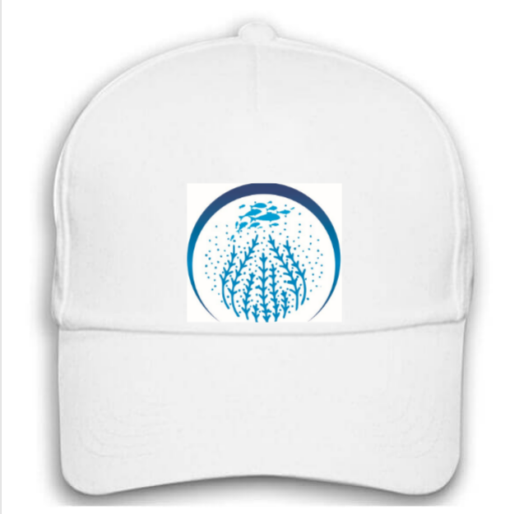

Cap 100 kgs

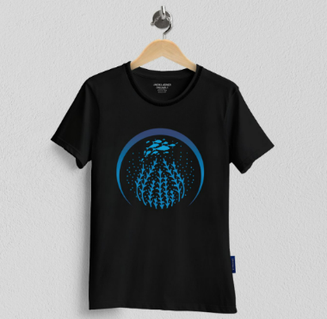

300 kgs

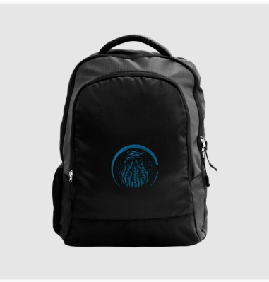

500 kgs



750 kgs

VseaweedO

Reference link

<https://www.seaweedandco.com/puresea-products/>

below design

IMAGE FRESH SEAWEED

**FRESH SEAWEED**

**Kappa ,Ulva, Cladophora, Brypsis, Caulerpa, Sargassum, Hydroclathrus, Porphyra, Gracilaria, Gelidium, Grateloupia, Hypnea, Rhodymenia** etc.

Add to cart

Price same for all products

Quaintly

**DRY SEAWEED**

**Kappa ,Ulva, Cladophora, Brypsis, Caulerpa, Sargassum, Hydroclathrus, Porphyra, Gracilaria, Gelidium, Grateloupia, Hypnea, Rhodymenia** etc.

IMAGE DRY

SEAWEED

IMAGE SEAWEED POWDER

SEAWEED Powder

**Kappa ,Ulva, Cladophora, Brypsis, Caulerpa, Sargassum, Hydroclathrus, Porphyra, Gracilaria, Gelidium, Grateloupia, Hypnea, Rhodymenia** etc.

Seaweed papad image of seaweed papad

Image seaweed laddu

Seaweed putharakulu images

Image SEAWEED TEA

Products

Refference sits

<https://www.seaweedandco.com/puresea-products/>



200 rs contribution for farming 50 rupees



200 rs contribution for farming 50 rupees



200 rs contribution for farming 50 rupees



200 rs contribution for farming 50 rupees